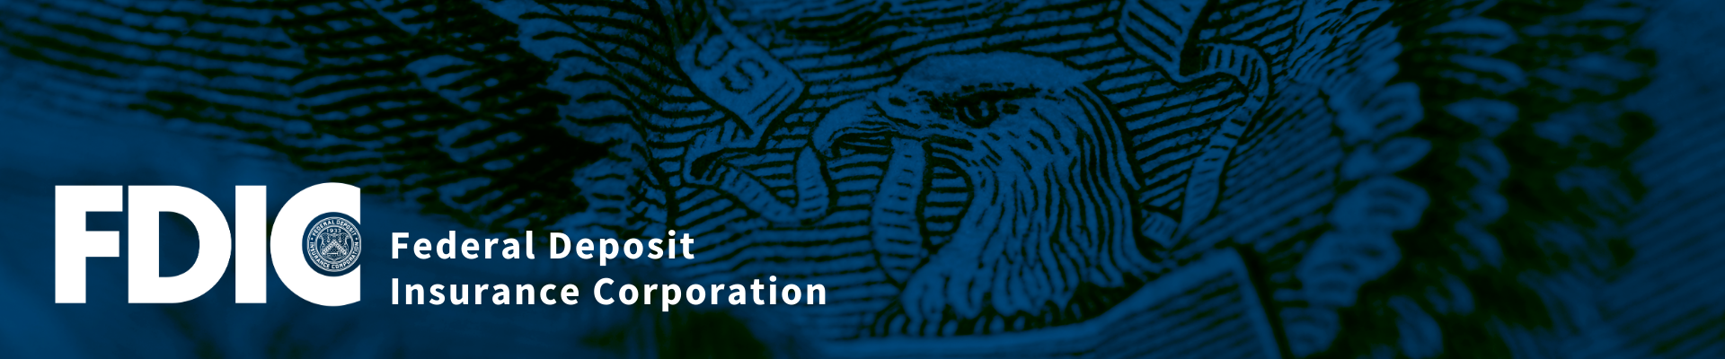

Economic Inclusion for Native Americans: Access to Safe and Affordable Accounts
Via Webinar
Wednesday, November 10, 2021
10:30 AM to 12:00 Noon CST

Agenda

10:30 to 10:45 Welcome, Webinar Overview & FDIC #Get Banked
Carla Tillmon, Community Affairs Specialist,
Federal Deposit Insurance Corporation

10:45 to 11:15 Access to Safe and Affordable Bank Accounts among Tribal Nations:
Barriers and Opportunities
Christy Finsel, Executive Director, ONAC
Karen Edwards, Manager, Native Bank On ONAC
Oklahoma Native Assets Coalition (ONAC)

11:15 to 11:45 Panel: Community Banks Offering Certified Accounts in Native Communities
Co-Moderators: Christy Finsel and Karen Edwards
Jason Brower, President - First State Bank of Anadarko
Jill Maple, Chief Financial Officer/EVP – AllNations Bank

11:45 to 11:55 Questions & Answers

11:55 to 12:00 Next Steps & Adjourn

